**Department of Spanish and Portuguese Studies**

**University of Florida**

**SPN 2201: Intermediate Spanish II**

Spring 2018

|  |
| --- |
| Spanish & Portuguese Studies Department: http://www.spanishandportuguese.ufl.edu  Syllabus available for download and printing: http://bit.ly/UFldsp |

|  |  |  |  |
| --- | --- | --- | --- |
| **Instructor: Clara Sotelo** | **Section**: Honors | | **MSL course code:** |
| **Office**: 155 Dauer Hall | | **Office hours: TBD** | |
| **Classroom**: | | **Email: wandy@ufl.edu** | |

**REQUIRED MATERIALS**

* **¡*Anda! Intermedio* 3rd Edition package** (Do **NOT** buy the 2nd edition of *¡Anda! Intermedio*). This package includes everything you need for the course and can be purchased at any local bookstore. It is available in a white 3-ring binder. No used copies are available, and a 1st edition copy (or previous UF editions) will not be acceptable.
* A printed copy of this syllabus, available from http://[bit.ly/UFldsp](https://mail.ufl.edu/owa/redir.aspx?C=eWOFdrQ0WU2SsuUBf0KvMvBkw5FDidEIfQMAwhGGan0vt-Nh3uTFNuMkEVFoSFAeE5ao7kyIqa4.&URL=http%3a%2f%2fbit.ly%2fUFldsp) or [http://ufspssyllabi.wikispaces.com](http://ufspssyllabi.wikispaces.com/)
* A reliable computer, either a PC running Windows 2000 or later, or Mac running OS X or later. **Check MySpanishLab tune-up for browser specifications.**
* A sound card and speakers or headphones.
* A hi-speed modem (Cable or DSL strongly recommended to download audio and video without delays).
* A dependable Internet Service Provider (ISP).
* A working UF e-mail address that you ***check daily*** and keep under quota.

**RECOMMENDED MATERIALS**

* A good quality Spanish-English dictionary, such as University of Chicago.
* *601 Spanish Verbs* book, available at most major booksellers.
* A good quality computer microphone (external is preferable to built-in to avoid the background noise).

**PREREQUISITES**

SPN 2200 or Placement Exam (See Undergraduate Catalog for SAT II, CLEP, AP and IB scores and/or the Test

scores and placement in Lower Division Spanish.

**COURSE GOALS AND OBJECTIVES**

The primary goal of SPN 2201 is to provide students with a review of previously learned Spanish and to help them acquire new communicative skills in Spanish while developing an awareness and appreciation of Hispanic/Latino cultures. The Lower Division Spanish Program courses take their goals from the *Standards for Foreign Language Learning in the 21st Century*, also known as the 5Cs, which focus on five general areas:

* Communicating in Spanish
* Gaining knowledge and understanding of cultures of the Hispanic world
* Connecting with other disciplines and acquiring new information
* Developing awareness of similarities and differences (comparisons) among language and culture systems around the world
* Using Spanish to participate in communities at home and around the world

With these standards in mind, each student in SPN 2201 should be able to:

1. comprehend Spanish spoken at normal speed on a variety of selected topics in various formats.
2. use conversational skills in a variety of communicative situations.
3. accurately read and understand cultural and literary material.
4. produce written Spanish to meet practical needs as well as creative expression.

**METHODOLOGY AND ACTIVITIES**

To help students succeed in these courses, the class will engage in a variety of activities and assignments, including but not limited to activities such as the following:

* Practice and communication using vocabulary and grammar learned in oral and written modes
* Sociolinguistic practice and functions through communicative activities (pair and group work)
* Reading activities and exercises, such as pre- and post-reading, intensive and extensive reading
* Writing activities ranging from short paragraphs to developed compositions
* Integration of skills in projects and tasks, in small groups or as a class
* Video/audio/computer exercises, presentations, and discussions

**ASSESSMENT**

The final grade scale is as follows:

|  |  |  |  |
| --- | --- | --- | --- |
| A = 100-93 |  | C (S) = 76-73 | NOTE: A grade of C- will not be a qualifying grade for major, minor, Gen Ed, Gordon Rule or Basic Distribution Credit courses. For further information regarding passing grades and grade point equivalents, please refer to the Undergraduate Catalog at (<http://www.registrar.ufl.edu/catalog/policies/regulationgrades.html>). |
| A- = 92-90 |  | C- (U) = 72-70 |
| B+ = 89-87 |  | D+ = 69-67 |
| B = 86-83 |  | D = 66-63 |
| B- = 82-80 |  | D- = 62-60 |
| C+ = 79-77 |  | E = 59-0 |

The assessment categories below will be measured according to three major criteria of language performance: accuracy, fluency, and complexity. Testing procedures will be representative of the type of language instruction offered through classroom practice. You will be evaluated based on your achievement of the course goals (above) and the following criteria:

Class Preparation & Participation 10%

Online Quizzes via MSL (5) 10%

MSL Assignments 10%

Compositions (2) (7.5% each) 15%

Oral Tasks (2 ECAs, 1 Oral Exam, 1 Presentation) (6.25% each) 25%

Exams: Midterm Exam (12.5%) and Final Exam (17.5%) 30%

100%

**COMPONENTS**

**Attendance policy**

You must be exposed to Spanish and use Spanish regularly in order to learn Spanish. That is, you must be in class! For that reason, attendance is required and will be taken on a daily basis. You will be allowed THREE UNEXCUSED ABSENCES for which no documentation or excuse is required. After the **THIRD unexcused** absence, **ONE PERCENTAGE POINT PER ABSENCE** will be deducted from your final grade. **If you are absent the day of a test, quiz, oral exam or composition, you will receive a 0 on that assignment. There are no make-ups and no exceptions for unexcused absences.** Three late arrivals and/or early departures will count as one absence.

Assignments are due on the day indicated, regardless of whether or not you are in class that day. If you miss class, arrange for your assignment to get to your instructor’s mailbox in 170 Dauer Hall before your scheduled class time. There are no make-ups and no late work will be accepted. Make sure to get the name and phone number of a classmate, as you are responsible for finding out about any changes in the syllabus or any additional assignments announced in your absence.

**In the case of university-approved absences** (i.e., illness, university-sanctioned events, etc. – refer to your undergraduate catalog), **you must provide official documentation to your instructor within one calendar week of the absence in order to be excused**. If you do not do so, the absence will be unexcused! Any work missed due to excused absences will be handled on a case-by-case basis in conjunction with advice from the program administrator.

**Student Preparation and Participation (See the rubric included in this syllabus)**

Maximizing your language learning involves a lot of preparation outside of class as well as active participation in class. Your grade in this category involves a number of variables, including but not limited to:

1. Evidence of your daily preparation for each class.
2. Your use of Spanish in the classroom
3. Your willingness to participate actively in *all* class activities
4. Your cooperation during group and pair work
5. Your respect and attitude toward the class and your support for the learning process of your peers
6. Your instructor will likely assign written or oral homework, in-class work, and/or administer quizzes that will be collected, evaluated, and counted towards your daily preparation for class.
7. **The use of electronic equipment during class for anything other than participating in class activities is prohibited unless otherwise indicated by your instructor. Using a cell phone during a composition or test will result in a zero on that assignment.**

Student preparation and participation grades will be posted and updated on MSL two times during the semester. See dates on the calendar.

**EXAMS (30%) (See information on MSL 🡪 Course Materials 🡪 Evaluaciones)**

There will be two written exams administered face-to-face, a midterm and a final. The midterm exam will be given during one class period and the final exam will be given during the final exam week (see Calendar for specific dates). The goal of the exams is to assess your ability to assimilate what you have learned about Spanish grammar, vocabulary, language, and culture. You are also expected to critically respond to and analyze the topics covered in class and in the texts. Tests will consist of writing, listening, and reading sections in which your overall knowledge of the course material is evaluated. Both the midterm and the final exam are cumulative. Tests are not curved and no make-up tests will be given. NO DEVIATION OF THE TEST SCHEDULE WILL BE ALLOWED, UNDER ANY CIRCUMSTANCES; this means NO early or late exams. It is YOUR responsibility to ensure that you will be present for both scheduled exams.

**ONLINE CHAPTER QUIZZES (10%)**

In order to periodically assess your learning of the material, there will be an online quiz at the end of each chapter, administered through MySpanishLab. You will take a total of 6 quizzes and the lowest grade will be automatically dropped. These quizzes will be scheduled to be completed within a 39 hour time period following the completion of each chapter’s material in class (see Calendar below for details). While you will be allowed to use your class notes to help you complete the quizzes, you will not be able to access and online materials or your e-book. The quizzes are timed (50 minutes) so that it is in your best interest to work on your own. The quizzes are designed to be able to be completed successfully if you have been diligent about doing your MySpanishLab activities and attending and participating in class, and well-prepared students will not need to use valuable time consulting additional resources. If you are not satisfied with your grade on a quiz, you can retake each quiz once, within the 39 hour time period it is assigned, in order to get a higher grade. So don’t wait until the last minute to take it the first time! **A green flag appears on the calendar the day each quiz becomes available at 8:00 a.m., and you must complete it before the 11:59 p.m. deadline the following day.** Your grade on the quiz will appear in the Gradebook. Practice tests are available in each chapter on MSL 🡪 Course Materials 🡪 Chapter 🡪Additional Practice 🡪 Practice test with study plan. If you believe a correct answer has been scored incorrectly, alert your instructor immediately.

**Perform the MySpanishLab (MPL) browser tune-up prior to each quiz attempt and any time you experience problems doing homework. ANY other technological problems with MySpanishLab should be handled by contacting Pearson tech support (**[**support.pearson.com/getsupport**](http://support.pearson.com/getsupport)**) AT THE FIRST SIGN OF TROUBLE. The ‘chat’ feature is the fastest way to get help and to document communication with Pearson. Any technological problems that cause you to miss a deadline MUST be documented through Pearson tech support with an official case number and a transcript of the chat and/or phone communication.**

**Also, you must DOCUMENT any trouble you are having with MSL by taking screen shots or video of your computer screen to show the issue as you experienced it. Your instructor will require the official incident report number, the transcript of your chat/phone conversation, and your evidence WITHIN 24 HOURS of the issue in order to follow up. If you do not provide all of this information within 24 hours, no action will be taken.**

**See the sections “Maximize Your Spanish Learning Using MySpanishLab” and “Important Information for MSL” after the Calendar at the end of this syllabus to learn more about enrolling in MSL, troubleshooting technical issues, etc.**

**MYSPANISHLAB ACTIVITIES AND HOMEWORK (10%)**

You will be assigned a variety of homework assignments from the MySpanishLab site, consisting of readiness checks, tutorials, grammar exercises, listening and writing practice, etc. You are responsible for completing all the assigned activities. **The online exercises that are assigned will appear in the MySpanishLab calendar on the dates assigned; all MSL exercises are due by 8:00 a.m. that day (that is, before class that day).**  Most of these exercises are computer-graded and you will receive immediate feedback regarding your answers. Note that it is in your best interest to study the material in the book and view the assigned tutorials before you do the assigned exercises. You have a maximum of three attempts on the activities, and the highest grade of the three will be your

final grade for each activity. If there are incorrect answers on your first submission a small blue bubble will

appear beside the answer. Click on it for a hint, review the material again, and then click on “try again” to make

the correction. If your second attempt is also incorrect a “need help?” button will appear in the upper right-hand corner of that window. Click on it to review the material you got wrong, and then click on the “try again” button to make the correction. If your answer is still incorrect after three tries, the correct answer will appear when you click on the small blue bubble next to the incorrect answer, but you will no longer be able to submit an additional attempt at that point. The resulting grades of all activities assigned for each chapter will be averaged, and that score is what will be calculated as your MSL homework grade. Note that any exercises in MSL marked “Extra Practice” are not graded. If you believe a correct answer has been scored incorrectly, alert your instructor immediately.

**WRITING COMPONENTS (15%): 2 COMPOSITIONS (15%)**

**(See the rubric at the end of this syllabus + information on MSL 🡪 Course Materials 🡪 Evaluaciones)**

You will practice your writing throughout the course. Your instructor will ask you to write informally on topics throughout the semester and offer you feedback. Informal writing assignments – along with others your instructor deems important for your progress in the course - will count towards your participation grade.

More formally, you will write two (2) compositions of about 250-350 words each on topics selected by the instructor. The first draft of each composition will be written in class (see dates indicated in the Calendar), and the rewrite/final version will be written at home. Your instructor will make comments and mark errors (with the symbols indicated in the “Correction Code”). You will then revise the composition and turn in the second version along with the first version for the final grade on the date specified by your instructor; this revision will count towards the overall Composición grade. All compositions (original draft and final version)must be double-spaced. The second version will not be accepted without the first. You must type and double space all second drafts. You must also highlight anything that is different from the first draft, and include a word count.

**All work that you turn in for a grade must be your own original work. The use of computer- or internet-based translation programs is not allowed. NO ONE, STUDENT OR NOT, should LOOK at your composition, suggest changes, or make corrections. Any evidence of disallowed resources or work that is not a product of a student’s own intellectual process will be handled according to the student honor code policy.**

**Oral Components (25%)**

**(See the rubrics at the end of this syllabus + information on MSL 🡪 Course Materials 🡪 Evaluaciones)**

Your spoken language component consists of four parts: Two “Effective Communication Assessments” (12.5%), one oral exam (6.25%), and an in-class culture report (6.25%). **If a student arrives after the ECA / Oral Exam has begun, the student will not be allowed to participate and will receive a zero for the assessment.**

* **The** **Effective Communication Assessment** **(ECA)** takes place twice during the course. Students will sign up with a partner to come the first day or the second of the corresponding ECA to use, as naturally as possible, your conversational skills. You will be in class according to your grouping, time during which you will converse on the topics covered so far. Your instructor will evaluate your casual conversations by walking around the classroom and listening to each group during several occasions.
* For the **oral exam** you will spontaneously converse (no notes!) with a fellow classmate of your choice. Instructions and a sample topic (see the document in the Evaluaciones folder) will help you prepare for the oral exam. You will choose a partner, and your instructor will have you both sign up for the exam in advance. This time, you’ll only have to come to class at the specific time you signed up for, and leave as soon as you are done. Grades will be assigned according to the grading criteria in the syllabus. Your conversations must be about 5 minutes long.
* For the **in-class cultural presentation** you will discuss a topic of interest to you *that is specifically related to the theme of the chapters* covered in the textbook and that *is* ***very specific in its focus***. At the beginning of the course your instructor will discuss possible ideas or areas of interest and will explain the procedure of the presentation in detail.

At the beginning of the course, your instructor will also distribute a sign-up sheet, which includes presentation dates throughout the course (2 or 3 presentations per chapter, starting on the 3rd week). You will select a topic, research it, and present it to the class in about 3 minutes on the scheduled date.

At least 3 classes before your presentation, you must provide your instructor with an outline (not a script or summary) in Spanish of the main points of your presentation, as well as bibliographic reference to any and all sources consulted in gathering the information for the presentation. You should also share with your instructor any visual aids you will use so that s/he can give you feedback and the handout you will share with classmates.

On the day of your presentation, you must provide a handout (in Spanish) for your classmates that includes basic information for your topic as well as any new vocabulary words with which your peers might not be familiar. You should also consider some sort of **interactive activity to engage your classmates** during your presentation. It is required that you incorporate some kind of visual aid during your presentation, such as photos, a poster, a PowerPoint and/or images included in the handout to aid in your classmates’ interest and comprehension of the material. Your visual(s) should have little text (titles and labels only).

**Presentations are *not* to be read**, although you may refer to ONE note card containing key vocabulary words, reminders of main ideas, etc. The presentations should be practiced and prepared, but ***not memorized or scripted*. The instructor reserves the right to deny the acceptability of any presentation that is wholly or partially read or scripted, resulting in a 0.**

Grades will be assigned according to the criteria provided in the syllabus.

***Note****:* **Every student will be responsible for the information provided during all in-class presentations and follow-up discussions throughout the course of the semester. To this end, questions related to these presentations will be included on the midterm and final exams.**

**GENERAL ADMINISTRATIVE ISSUES**

**Expected Time Required (Approximate):** A general guideline for the amount of time you should plan to dedicate to this and any other University course is 2-3 hours of homework per hour in class per week. **That’s 6-9 hours a week that you should plan to spend outside of class for this course!**

**Extra Credit:** No extra credit will be given under any circumstances. There are NO EXCEPTIONS.

**Late and Make-up Work:** Tests, compositions or writing activities will not be administered EARLY UNDER ANY CIRCUMSTANCES. If you cannot take an announced test due to an emergency, OFFICIAL WRITTEN proof of the circumstances must be presented to your instructor no later than the day after you return to class. Medical excuses must be in writing on physician’s letterhead, and must have a statement “could not attend class", as well as the inclusive dates in which the student could not attend. A receipt from a physician or ER is not acceptable. Acceptable funeral excuses are a letter from a funeral home, or clergy person, on letterhead, indicating attendance at the funeral or service. At the Administrative Coordinator’s discretion, an average of two tests may substitute for a make-up.

**Incompletes:** The Lower Division Spanish Program abides by the University policy on Incomplete grades (http://www.registrar.ufl.edu/staff/grades.html#incomplete) and we will NOT assign any I grades except under truly exceptional extenuating circumstances. You MUST arrange a meeting with your instructor and with the Administrative Coordinator, Prof. Antonio Gil, if you believe your situation qualifies for consideration

**S/U Option:** You are free to take this course S/U if you desire, even if you are a major or minor (the first course that counts towards the degree and that therefore must be taken for a grade is 2240). Here is what you must do:

* Print out a S/U form from: <http://www.registrar.ufl.edu/pdf/SUgradeoption.pdf>.
* Fill out the top portion ***completely***and sign on line #4.
* Obtain the relevant signatures. Signatures #1 and #2 can be obtained from **170 Dauer Hall** during business hours. Signature #3 should be the last one, which can be attained by visiting college dean’s office. Incomplete forms will not be signed by the department nor the college.
* Please be aware that the S/U deadline is during the first three weeks of class. You can only take **1 course** S/U per term.

**Use of technology:**  Use of MSL and email are essential elements of this class. MSL serves as the course text / workbook and should be viewed and used daily. Email may be used to communicate with the instructor and other class members, and thus you are required to **check your UF email daily**. **In class, the use of cell phones, pagers, iPods or mp3 players and all other electronic equipment during class is prohibited unless explicitly indicated by your instructor. All equipment should be silenced and off desks.** Any evidence of active cell phone and/or similar equipment use not related to a class activity will result in an automatic zero in participation for that day. Using a cell phone or any other technology not explicitly approved by the instructor during a composition or test will result in a zero on that assignment.

**CLASSROOM DISPUTES**

Any classroom issues, disagreements or grade disputes should be discussed first between the instructor and the student. If the problem cannot be resolved, contact Prof. Antonio Gil ([agil@ufl.edu](mailto:agil@ufl.edu), 160 Dauer Hall). He will require documentation of the problem as well as all graded assignments for the semester. Final grades cannot be changed unless there is an error. Students must present the **graded** materials as evidence that a mistake was made.

**UNIVERSITY POLICIES**

**Academic Integrity:** All students are required to abide by the Academic Honesty Guidelines, which have been accepted by the University. The UF Honor Code reads:

*We, the members of the University of Florida community, pledge to hold ourselves and our peers to the highest standards of honesty and integrity.*

**On all work submitted for credit by students at the University of Florida, the following pledge is either required or implied: “On my honor, I have neither given nor received unauthorized aid in doing this assignment.”** For more information on types of academic violations and the process should one be charged with committing an academic violation, please refer to <https://www.dso.ufl.edu/sccr/process/student-conduct-honor-code/>.

**Accommodations:** Students requesting classroom accommodation must first register with the Dean of Students Office. The Dean of Students Office will provide documentation to the student who must then provide this documentation to the Instructor when requesting accommodation. For more information see <http://www.dso.ufl.edu/drc>.

**Counseling and Wellness:** A variety of counseling, mental health and psychiatric services are available through the UF Counseling and Wellness Center, whose goal is to help students be maximally effective in their academic pursuits by reducing or eliminating emotional, psychological, and interpersonal problems that interfere with academic functioning. The Center can be found online at <http://www.counseling.ufl.edu/cwc> or reached by phone at 392-1575.

**Course Evaluations**

Students are expected to provide feedback on the quality of instruction in this course based on 10 criteria. These evaluations are conducted online at <https://evaluations.ufl.edu>. Evaluations are typically open during the last two or three weeks of the semester, but students will be given specific times when they are open. Summary results of these assessments are available to students at <https://evaluations.ufl.edu/results>.

**COURSE FEE**

Upon registration, you were charged a nominal fee by the Spanish and Portuguese Studies department to enroll in this course. Those funds are used to cover the costs of copying materials used in assessment and evaluation throughout the semester. Additional course fees were charged by the Language Learning Center (http://www.clas.ufl.edu/llc) for the maintenance and upkeep of their resources and equipment for all language students.

**CALENDARIO (*)**

**“Comunidad”: ¿Cómo definimos comunidad? ¿A cuáles comunidades pertenecemos y cómo son?**

(*) Note that changes to the syllabus may be made as necessary. Any changes will be announced via chapter homework documents, emails from the instructor, and/or announcements in class in advance.

| **Fecha** | **PREPARAR PARA CLASE** | |
| --- | --- | --- |
| *Capítulo: Páginas en texto para estudiar* | *En MySpanishLab: Hacer actividades después de estudiar texto (entregar antes de las 8:00 de la mañana para ejercicios / antes de las 11:59 de la noche para quizzes)*  **CHECK the MSL calendar DAILY** to do assigned activities, which go with the topics covered in class & the textbook pages that you have to study before class. MSL exercises are due by 8:00 a.m. the day of class. Quizzes are due by 11:59 p.m. on the date indicated on the calendar. **Late submissions are not accepted!**  *Otras actividades importantes* |

| **Enero**  8 | Course intro | **Purchase book! *Enroll in MSL, and***  ***check for assignments immediately!*** |
| --- | --- | --- |
| 10 | **Capítulo B:** **¿Cómo definimos comunidad? ¿A cuáles comunidades pertenecemos?**  págs. 268-279 | <-- Páginas del texto: Estudiar **antes** de clase  para estar list@ para las actividades  interactivas en clase.  *The note on 08/28 on the MSL calendar lists*  *the suggested activities that students*  *should complete prior to today’s class*  *(due on 08/28).* |
| 12 | Capítulo B: 279-299 | *The note on 08/28 on the MSL calendar lists*  *the suggested activities that students*  *should complete prior to today’s class*  *(due on 08/28).* |
|  |  |  |
| 15 | **No hay clase** | **Martin Luther King, Jr. Day** |
| 17 | **Capítulo 7: ¿Qué hay en nuestras comunidades?**  300-307 | *All Capítulo B activities in MSL are due today!*  *Antes de venir a clase, lea el documento sobre el*  *“Informe oral” en la carpeta “Evaluaciones” en MSL*  *Quiz Cap B*: Abre hoy y cierra mañana. |
| 19 | Capítulo 7: 308-315 + Appendix (in back of book) A39-40 | *Informe oral*—Firme la hoja del instructor |
|  |  |  |
| 22 | Capítulo 7: 308-315 + A39 | Último día de anotarse para *Informe oral (y hacer preguntas.)* |
| 24 | Capítulo 7: 326-329  Leer / Escuchar / Hablar | Comienzan “Informes Orales” en clase. |
| 26 | Capítulo 7: 330-339  Leer / Escuchar / Hablar | *Quiz Cap 7*: Abre hoy y cierra mañana  *(S/U option deadline – sept. 8)* |
|  |  |  |
| 29 | **Capítulo 8:** **¿Cuáles son las opciones de empleo en nuestras comunidades?**  340-351 | *Antes de venir a clase, lea el documento sobre la Effective Communication Assessment (ECA) #1 en la carpeta “Evaluaciones” en MSL.* |
| 31 | Capítulo 8: 352-360 | *Antes de venir a clase, lea el documento sobre la Composición en la carpeta “Evaluaciones” en MSL.* |

| **Febrero**  2 | | Capítulo 8: 343-350 + A27 | *Anótese con un compañero para ECA #1.* |
| --- | --- | --- | --- |
|  | |  |  |
| 5 | | Capítulo 8: 370-377 | *Empiece a prepararse para la Composición y ECA #1* |
| 7 | | Capítulo 8: 378-391  Leer / Escuchar / Hablar | *Quiz Cap 8*: Abre hoy; cierra mañana. |
| 9 | | **Composición 1** | *La Composición #1 se escribe hoy (lea el documento sobre la Composición en la carpeta “Evaluaciones” en MSL). Prepárese repasando el vocabulario, la gramática y los temas culturales de los capítulos estudiados. Traiga el libro; podrá usarlo durante los primeros 10 minutos preparatorios (además de su texto y sus apuntes).* |
|  | |  |  |
| 12 | | **ECA 1 (Día 2)** | *Venga a clase solo si firmó para su ECA este día.* |
| 14 | | **ECA 1 (Día 2)** | *Venga a clase solo si firmó para su ECA este día.* |
| 16 | | **Capítulo 9:** **¿Qué es el arte? ¿Cómo representan las historias, los valores, etc. de las comunidades?**  392-396 + A34-35 | *Nota de Participación #1* |
|  | |  |  |
| 19 | | Capítulo 9: 397-403 | *Práctica con los diversos casos del subjuntivo.*  *Lea la información sobre el examen de mitad (midterm exam) en la carpeta “Evaluaciones” en MSL.* |
| 21 | | Capítulo 9: 410-418 + A38 |  |
| 23 | | Capítulo 9: 419-423 | *Estudie para el examen parcial (midterm exam)* |
|  | |  |  |
| 26 | | Capítulo 9: 424-437 | *Quiz Cap 9*: Abre hoy y cierra mañana |
| 28 | | **Repaso / Midterm exam (comprensión oral + cultura)** | **Examen parcial (sobre Capítulos Preliminar B a 9)** |
| **Marzo**  2 | | **Midterm Exam (written)** | **Examen parcial (sobre Capítulos Preliminar B a 9)** |
|  | |  |  |
| 5-9 | | **No class** | **Spring Break** |
| 12 | | Capítulo 10: **¿Cómo afectan nuestras acciones al medio ambiente y cómo nos afecta el medio ambiente?**  438-447 + A41-A42 | *Antes de venir a clase, lea el documento sobre la Composición en la carpeta “Evaluaciones” en MSL.* |
| 14 | | Capítulo 10: 448-456 + A42 | *Antes de venir a clase, lea el documento sobre el Examen oral en la carpeta “Evaluaciones” en MSL* |
| 16 | | Capítulo 10: 457-463 |  |
|  | |  |  |
| 19 | | Capítulo 10: 464-469 | *Anótese con un compañero para el Examen oral.* |
| 21 | | Capítulo 10: 470-479  Leer / Escuchar / Hablar | *Quiz Cap 10*: Abre hoy; cierra mañana. |
| 23 | | **Composición 2** | *La Composición #2 se escribe hoy (lea el documento sobre la Composición en la carpeta “Evaluaciones” en MSL). Prepárese repasando el vocabulario, la gramática y los temas culturales de los capítulos estudiados. Traiga el libro; podrá usarlo durante los primeros 10 minutos preparatorios (además de su texto y sus apuntes).* |
|  | |  |  |
| 26 | | **Oral Exam (Día 1)** | *Venga a hacer su Examen oral si firmó para este día.*  *Lea la información sobre el Examen oral en la carpeta “Evaluaciones” en MSL.* |
| 28 | | **Oral Exam (Día 2)** | *Venga a hacer su Examen oral si firmó para este día.*  *Lea la información sobre el Examen oral en la carpeta “Evaluaciones” en MSL.*  *Si la clase es pequeña, su instructor/a usará esta clase como día de repaso / enriquecimiento.* |
| 30 | | **Oral Exam (Día 3)** | *Note: Venga a hacer su Examen oral si firmó para este día.*  *Lea la información sobre el Examen final en la carpeta “Evaluaciones” en MSL.*  *Si la clase es pequeña, su instructor/a usará esta clase como día de repaso / enriquecimiento.* |
|  | |  |  |
| **Abril**  2 | | **Capítulo 11:** **¿Somos sanos en EEUU? ¿Cuáles son los problemas de salud que enfrentan comunidades?**  480-487 + A32-33 |  |
| 4 | | Capítulo 11: 488-498 |  |
| 6 | | Capítulo 11: 499-508 | *Antes de venir a clase, lea el documento sobre la Effective Communication Assessment (ECA #2) en la carpeta “Evaluaciones” en MSL.* |
|  | |  |  |
| 9 | | Capítulo 11: 509-517 |  |
| 11 | | Capítulo 11: 518-527  Leer / Escuchar / Hablar | *Quiz Cap 11*: Abre hoy y cierra mañana |
| 13 | | Capítulo 12: **¿Cómo definimos comunidad? ¿A cuáles comunidades pertenecemos y cómo son?**  528-544 | *Anótese con un compañero para la ECA.*  *Complete la evaluación del curso entre* *nov. 27 y dic. 8 en* [*https://evaluations.ufl.edu*](https://evaluations.ufl.edu)*,* |
|  | |  |  |
| 16 | | Capítulo 12: 545-555 | *Prepárese para la ECA #2.*  *Complete la evaluación del curso entre* *nov. 27 y dic. 8 en* [*https://evaluations.ufl.edu*](https://evaluations.ufl.edu)*,* |
| 18 | | **ECA 2 (Día 1)** | *Venga a hacer su ECA si firmó para este día.*    *Lea la información sobre el examen final en la carpeta “Evaluaciones” en MSL.* |
| 20 | | **ECA 2 (Día 2)** | *Venga a hacer su ECA si firmó para este día. Si la clase es pequeña, su instructor/a usará esta clase como día de repaso / enriquecimiento.*  *Lea la información sobre el examen final en la carpeta “Evaluaciones” en MSL.* |
|  | |  |  |
| 23 | Reflexión y repaso, Cap. B – 12 (énfasis Cap. 10-11)  ¿Cómo definimos comunidad? ¿A cuáles comunidades pertenecemos y cómo son? | | *Evaluación de Participación #2*  *¿Completaste la evaluación del curso? Tienes hasta el viernes 8.*  *Ve a:* [*https://evaluations.ufl.edu*](https://evaluations.ufl.edu)*,*  *Estudie para el examen final.* |
| 25 | **Final Exam Review** | |  |
|  | |  |  |
| **Final Exam** | | **Refer to** [**http://www.registrar.ufl.edu/soc**](http://www.registrar.ufl.edu/soc) **to find out when your section is scheduled to take its final exam. __________________________________**  **Final Exams go from April 30th to May 4th. SPN 2201 classes take the exam in their regular classrooms.** | |
| **Mayo**  **05** | | El último día con acceso a MSL para SPN 2201 (Vea su nota final antes de esta fecha.) | |

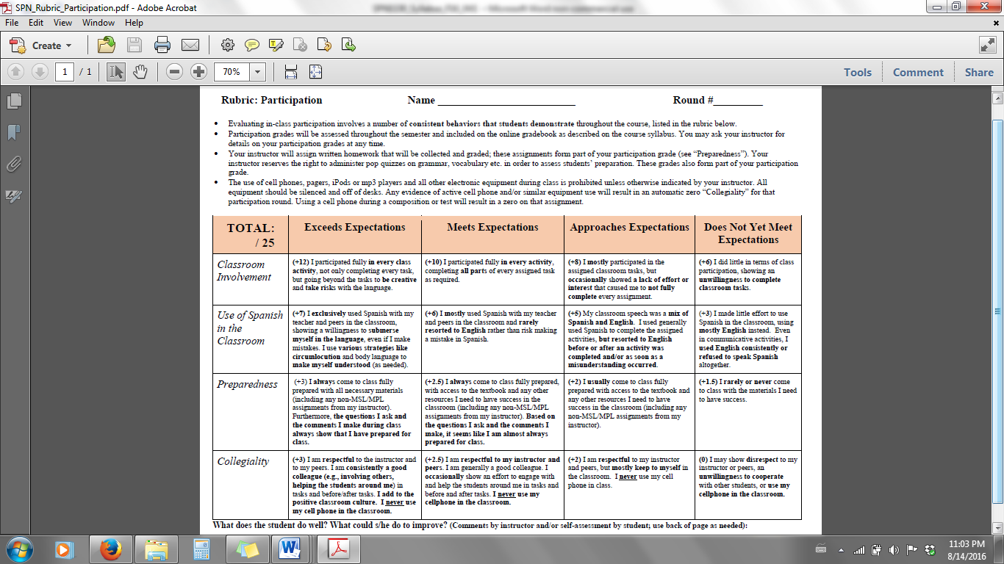

**CODES USED IN CORRECTING COMPOSITION**

**Your instructor will return your compositions having underlined words/phrases/sentences that need to be corrected. Above each underlined section there will be a symbol from the list below, which will indicate to you how to revise that portion of the composition.**

|  |  |  |  |
| --- | --- | --- | --- |
| **SYMBOL** | **ERROR TYPE** | **EXAMPLE (INCORRECT)** | **EXAMPLE (CORRECTED)** |
| **O** | **Spelling error** | ***huego*** | **juego** |
| **A** | **Accent mark error** | ***dia***  ***arból*** | **día**  **árbol** |
| **C** | **Agreement error (gender or number)** | ***Ellas son simpática*** | **Ellas son simpáticas** |
| ***La día*** | **El día** |
| **FV** | **Incorrect verb form or conjugation** | ***Me gusta nadando***  ***Yo sabo eso*** | **Me gusta nadar**  **Yo sé eso** |
| **TV** | **Incorrect verb tense** | ***Ayer estudia*** | **Ayer estudió** |
| **PP** | **Incorrect or missing preposition** | ***Pagó diez dólares para este libro*** | **Pagó diez dólares por este libro** |
| ***Trabajo a la tienda*** | **Trabajo en la tienda** |
| **PR** | **Missing or incorrect pronoun or relative pronoun** | ***Las son mis amigas*** | **Ellas son mis amigas** |
| ***Gusta bailar a él*** | **A él le gusta bailar** |
| ***Los estudiantes quienes viven en la Florida*** | **Los estudiantes que viven en la Florida** |
| ***Los estudiantes sus padres no viven en la Florida*** | **Los estudiantes, cuyos padres no viven en la Florida** |
| **LX** | **Lexical error, wrong word choice, or dictionary error** | ***Somos cansados*** | **Estamos cansados** |
| ***Yo lata mosca*** | **Yo puedo volar** |
| **[ ?]** | **Unintelligible** | ***Rewrite the section in [brackets] because it is incomprehensible or because it is not expressed that way in Spanish.*** | |
| **English phrase or construction** |
| **False cognate** |
| **X** | **Omit whatever element is crossed out** | | |
| **^** | **Insert missing element where mark indicates** | | |
| **+** | **Used to indicate two (or more) errors in the same construction** | | |

**¡OJO!**

* **Always consult this list of symbols when making corrections to your written work.**
* **Corrections should be made with a dictionary, verb book, textbook, class notes, etc. Do NOT**

**use translators (which are generally terrible)! Do NOT ask friends or family for help.**

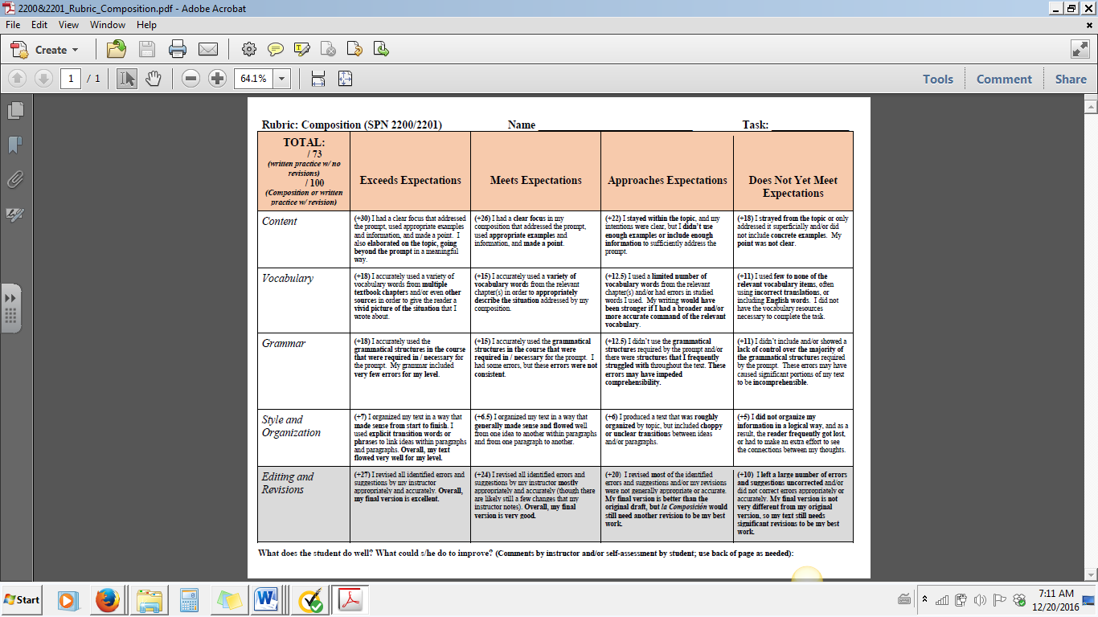

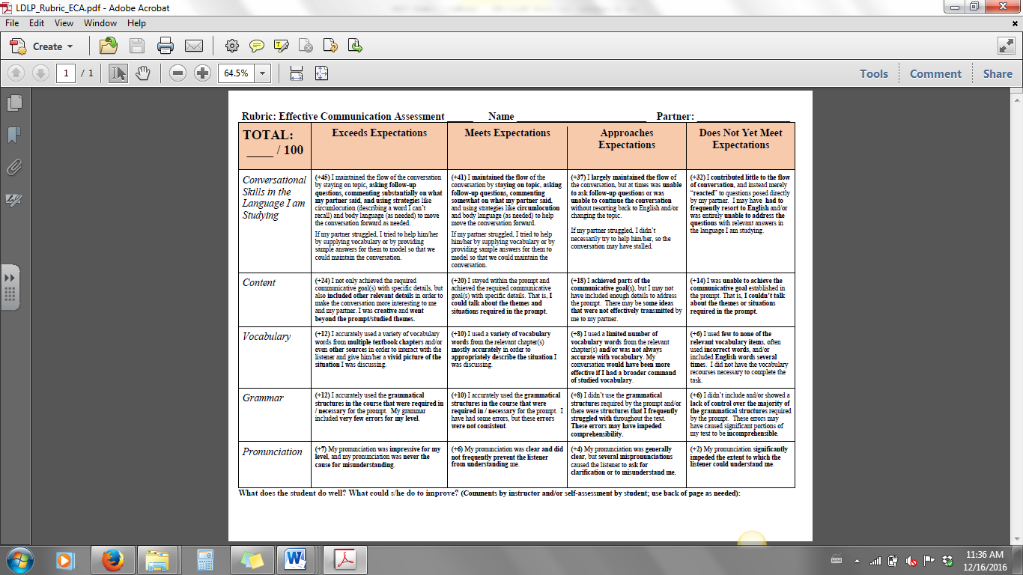

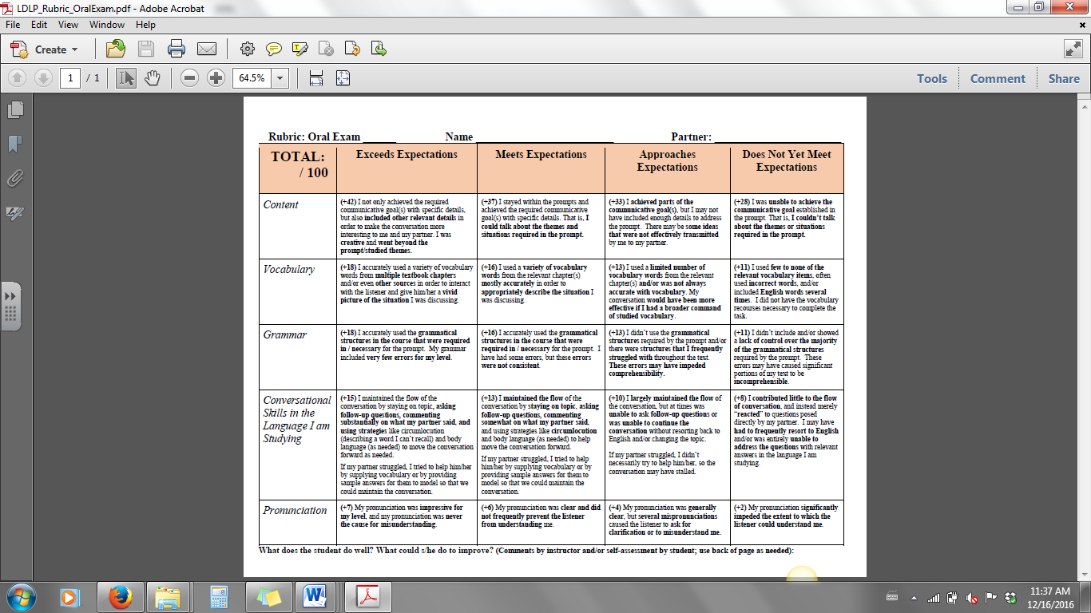

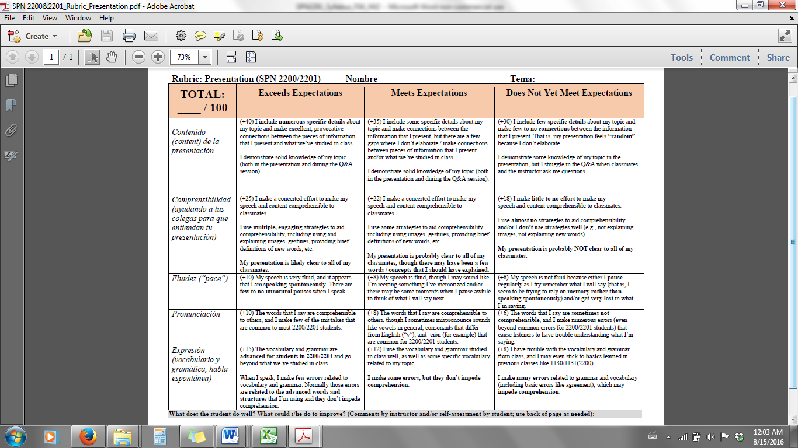

**Maximize Your Language Learning Using MySpanishLab (MSL)**

* MySpanishLab offers many resources for learning Spanish, including an e-book, pronunciation guide, review materials, flash cards, video and audio materials, a glossary, user’s guide, and many other tools to help you learn Spanish. Use them all!
* Using **the Calendar view** will always tell you what activities are due when. If you would like to explore what additional content is available to you for practice, click on “Course Materials” and select the chapter you would like to see in more detail.
* Each chapter is preceded by a **Readiness Check** that assesses your knowledge of ENGLISH grammar structures and prepares you for the Spanish grammar you will study. These readiness checks are assigned in order to ensure that you are prepared for the upcoming material, but are not factored into your grade.
* In the **Additional Practice** folder in each chapter, you will find a variety of opportunities to continue practicing on your own, including flash card you can download to a smart phone or use online, various games to help you learn vocabulary, practice tests, etc. You are encouraged to use these resources regularly.
* Within the **Chapter Resources** folder of each chapter you will find downloadable media, web links for the chapter, and other resources.
* Do the browser tune-up periodically to make sure you have the necessary software and plug-ins.
* **When you are doing an on-line chapter quiz, do not have any other windows open on your computer. If you leave the activity for any reason it will close.**
* **Do your own work. Violating UF’s honor code will not help you learn Spanish or get a better grade, and it will result in a student judicial honor code violation process.**

**Important Information on MSL**

**You must start submitting your work as assigned from the date of your enrollment in class.** As a general policy, late submissions are NOT accepted. The ONLY reasons to request acceptance of a late submission are:

1. Assignments were due before you enrolled in the course, according to the UF Registrar.

~ OR ~

2. You had documented technical problems when attempting to submit your work at least an hour before the assignment was due. Documentation in this case consists of your interactions (chat or email, or written follow-up to a phone conversation) with Pearson’s technical support. Only if Pearson confirms a technical problem on their end will your request be considered. (NOTE: You are also encouraged to document any issue in MPL via screen shot or video of your computer screen to show what the issue is as you experience it.)

In either case, **you must request concrete evidence for your case within 24 hours of the first missed deadline**. There are no exceptions.

NOTE: Repeated computer problems, crashes, failures to do the browser tune-up, etc. are NOT considered valid reasons for failing to turn in your work. There are plenty of computers available on campus for you to use, and all of the computers in the Language Learning Center have been formatted to work with MSL.

**If you happen to encounter technological problems with MySpanishLab, do the following:**

1. **_____ Contact Pearson tech-support (**[**support.pearson.com/getsupport**](http://support.pearson.com/getsupport)**) as soon as the problem happens.**

**2. _____ Send a copy to your instructor of all communications with Pearson, including an Incident Report number, copy of chat/phone transcript, etc. Also, include additional documentation (screen shot, video) of the issue as you experienced it.**

**3. _____ Save all communications with Pearson in case they get lost in cyberspace.**

When Pearson provides a definitive answer to the problem, a decision will be made on your case.

**NEW USER: Get Started with Pearson’s MyLanguageLabs**

**First, make sure you have these 3 things…**

**Email:** You'll get some important emails from your instructor at this address.

**Course ID:** Ask your instructor for your Course ID!

**Access code or credit card**: The required access code comes either with your book or by itself at your bookstore. Alternatively, you can buy instant access with a credit card or PayPal account during registration.

**Next, get registered!**

1. Go to [**www.mylanguagelabs.com**](http://www.mylanguagelabs.com).
2. Under the large **Register** section on the right side of the page, and click the **Student** button.
3. Read the onscreen instructions and click **OK! Register now.**
4. Next, choose one of the following: **Yes, I have an access code**, or **No, I need to buy access**. Either way, you’ll be asked to **Accept** the License Agreement before moving on.
5. After this, when asked if you have a Pearson Education Account, either select **No**, to **Create** a new Pearson username/password, or, if you’ve already registered for another Pearson product (i.e. MyMathLab), select **Yes** and enter that username/password. If you have an **Access Code**, enter it on the bottom of the page.
6. On the next page, fill out the appropriate information fields then click **Next**. If you entered an **Access Code**, you will be brought to a page from which you can access your product. If not, enter your payment information so that you can **Purchase Access**, after which you’ll be granted access.
7. You are now registered! Go to [**www.mylanguagelabs.com**](http://www.mylanguagelabs.com) and click the **Sign In** button.
8. The first time you login, you will be asked to ENROLL in your course. **You will need your instructor’s Course ID**. Contact your instructor for the course ID.
9. TIP: We recommend using Chrome or Firefox and making sure your Pop-up blockers are turned OFF.

**Need help?**

**Visit www.mylanguagelabs.com/get-registered for:**

• Helpful videos

• Frequently Asked Questions

• System Requirements

• Other helpful “getting started” info!

**Or visit our 24/7 Technical Support site at** [**support.pearson.com/getsupport**](http://support.pearson.com/getsupport)

Enroll in Your Next Semester Course:   
**Returning Student** with Multi-Semester Access

**If you have previously registered with Multi-Semester (24-Month) access, you can enroll in your next semester course without purchasing new MyLab access.* To check to see if you purchased Multi-Semester access, follow these steps: log in to your MSL account 🡪 My Profile 🡪 Edit My Pearson Account 🡪 Purchase History 🡪 Type of Access**

**First, make sure you have these 2 things…**

1. **Your Previous MyLanguageLab Account Username & Password:**

Since you bought multi-semester access, you’ll need to use the same username and password you created in a previous semester for your specific MyLanguageLab course/textbook.

1. **Course ID:** Ask your instructor for your Course ID! **Course ID: ______________**

**Next, enroll in your course!**

1. Go to [**www.mylanguagelabs.com**](http://www.mylanguagelabs.com).
2. Click the **Sign In** button on the right side of the page.
3. **Enter** your previous username and password**. Click Sign In.**
4. Once signed in, click the **Enroll in a Course** button on the top of the MyCourses page, and enter your **Course ID** (provided by your instructor). **Click Confirm.** You now have access to your course!

*\*Your Multi-semester access is only valid for the same textbook/edition MyLab course. If you are taking a new language course that is requiring a different textbook/edition, you will need to purchase a new access code for that course.* ***If you purchased access for only one semester, you must buy access for another semester for your current course!***

**Need help?**

**Visit** [**www.mylanguagelabs.com/get-registered**](http://www.mylanguagelabs.com/get-registered) **for:**

* Browser Tune Up & System Requirements
* Helpful videos
* Frequently Asked Questions
* Other helpful “getting started” info!
* **Or visit our 24/7 Technical Support site at** [**support.pearson.com/getsupport**](http://support.pearson.com/getsupport)

**Forgot your Username/Password?**If you need a username/password reminder [click here](https://register.pearsoncmg.com/forgotlogin/forgotLogin.fl), enter the email address used when you first registered and set up your account with your multi-semester access code and we’ll email your information to you.