CHEMISTRY in the COCINA LATINA
IDH 3931 (section 051F) | LAS 3930 (section 0978)
Wednesdays, periods 6-9

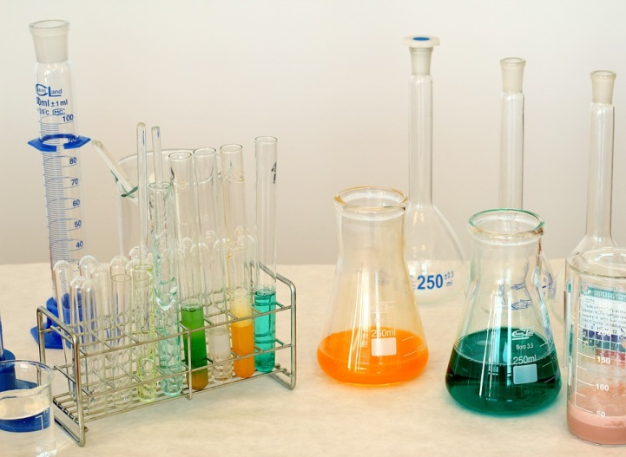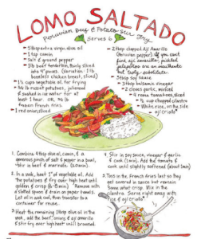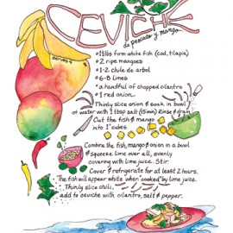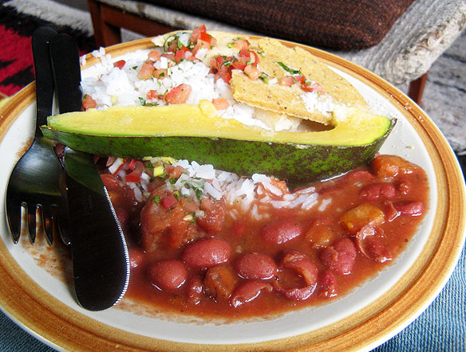

INSTRUCTOR INFORMATION
Dr. Valeria Kleiman | Dr. Gillian Lord
Office: 311B Chemistry Lab Building | Office: 170A Dauer Hall
Email: kleiman@chem.ufl.edu | Email: glord@ufl.edu
Phone: 352.392.4656 | Phone: 352.273.3749
Office hours: tba | Office hours: M 10-11:30, T 9-10:30

COURSE GOALS AND OBJECTIVES
This is a basic course that combines the science of chemistry with the humanistic aspects of the Spanish language and Hispanic cultures and histories. We explore Hispanic cultures and language through the foods and recipes that define them, and explore the science of those foods by studying the chemical reactions inherent in all cooking.
As part of the International Scholars Program, this course complies with the QEP Student Learning Outcomes identified by the UF International Center. As such, the course readings, activities and discussions will help students achieve the following:
- Students identify, describe, and explain global and intercultural conditions and interdependencies. Students will learn about various countries/regions in Latin America, and will understand cultural, historical, sociopolitical and geographical aspects of their culture. [content]
- Students analyze and interpret global and intercultural issues. Students will need to analyze and make sense of the various cultural, historical, sociopolitical and geographical factors that work together to form the Latin American countries/regions discussed. They will also explore the connections between food and culture, and food and science, and how the aforementioned factors are relevant to those connections. [critical thinking]
- Students communicate effectively with members of other cultures. Although no proficiency in Spanish is required, students will learn relevant vocabulary items and will come to appreciate the value of knowing another language. [communication]

COURSE MATERIALS
Required text (to purchase):
- Kriebel, Marcella. (2015). Mi Comida Latina: Vibrant, Fresh, Simple, Authentic. New Hope, PA: Lea Burgess Press. ($19.98 on amazon.com)

Other readings (selections will be provided in Canvas):
- Anderson, Benedict. (2006). Imagined Communities: Reflections on the Origin and Spread of Nationalism. New York, NY: Verso Books. [excerpts]
- Sucher, K., Kittler, P., & Nelms, M. (2016). Food and Culture, 7th ed. Boston, MA: Cengage Learning.
- On Food and Cooking: The Science and Lore of the Kitchen. By Harold McGee. Scribner and Sons (2015).

ASSESSMENT

Grade Scale and Policies

A = 100-93 | C(S) = 76-73 | NOTE: A grade of C- will not be a qualifying grade for major, minor, Gen Ed, Gordon Rule or Basic Distribution Credit courses. For further information regarding passing grades and grade point equivalents, please refer to the Undergraduate Catalog at https://catalog.ufl.edu/ugrad/current/regulations/info/grades.aspx.
A- = 92-90 | C-(U) = 72-70
B+ = 89-87 | D+ = 69-67
B = 86-83 | D = 66-63
B- = 82-80 | D- = 62-60
C+ = 79-77 | E = 59-0

Graded Course Components
The following components will be assessed to determine your final grade for the course. Each is described in further detail below.
- Attendance and class engagement = 10%
- Lab Activities (3) = 15%
- Kitchen Activities (3) = 15%
- Quizzes (3) = 12%
- Interview project = 18%
- Final project = 20%
- Oral presentation of final project = 10%

Attendance and class engagement = 10%
In order to engage with the course material and your classmates, attendance and active participation are expected at all class sessions. Missing class is not allowed, except for absences that are deemed acceptable by UF policy (see “POLICIES” section, below). In order for absences to be excused, they must be justified, properly documented, and discussed with the professor in a timely manner.
Rather than attempting to quantify an arbitrary “class participation” construct, in this class you will be assessed on any and all demonstrations of your willingness and ability to engage with the course material, with your classmates, and with your professors. Evidence of engagement can take many formats, ranging from (but by no means limited to):
- Offering thoughts and reactions to readings
- Asking questions in or out of class
- Treating classmates, colleagues, professors with respect
- Visiting office hours
- Sharing additional readings or resources with classmates
- Offering assistance/guidance/advice
We will keep track of your Engagement throughout the semester. Your final Engagement grade at the end of the term will be a holistic reflection of your overall semester efforts.

Lab Activities (3 @ 5% each) = 15%
On three occasions throughout the semester (January 25th, February 22nd, March 29th) class will meet in a chemistry laboratory space (Leigh Hall 108) in order to carry out the experiments and reactions that have been discussed during that unit. During these class periods, you will receive worksheets to complete as you carry out the experimental portion of the class. Your successful completion of these activities depends upon your thorough preparation for the lab period (i.e., reading the lab procedure prior to class), your active participation in all classroom activities, your adherence to proper lab safety protocols, and your ability to work well with your lab partner(s).

Kitchen Activities (3 @ 5% each) = 15%
On three occasions throughout the semester (February 1st, March 1st, April 5th) class will meet in the Institute of Food and Agricultural Science (IFAS)’s kitchen space, located in the Food Science and Human Nutrition Lab Building, to prepare the recipes associated with that unit.
- Preparation: Prior to each of these visits, you will be expected to review the recipes from the text. Additionally, you will be asked to identify certain ingredients from the recipes and determine a chemical compound associated with that ingredient, along with providing the chemical structure and name of each compound. This will be completed on Canvas prior to each kitchen activity.
- Cooking: During class you will prepare the dish(es) following the book instructions and with instructor guidance.
- Recipe guides: During and after the preparation of each recipe, you will prepare a step-by-step how-to guide, complete with images (photos, illustrations) and directions. You will be assigned a particular recipe to document for each kitchen visit, and will complete the guide in groups. Your guide will be submitted on Canvas, and can be in any multimedia format (slideshow, video, bulletin board, etc.) you choose.

Quizzes (3 @ 4% each) = 12%
There will be periodic quizzes during class time (January 18th, February 15th, March 22nd) to assess your understanding of the basic concepts and vocabulary covered in class. These quizzes will contain items relating to Spanish lexical items, Hispanic/Latino culture and history, and chemical compounds, reactions and processes. If you prepare for class and are present and involved in class lectures and discussions, you will be prepared for these quizzes.

Interview project (18%)
In addition to the content and critical thinking goals of this course, our communication objective aims to connect you with members of the Hispanic/Latino community. To that end, you will need to carry out an interview with a Hispanic/LatinX person to learn more their relationship with food and food in their culture. The person you interview can NOT be an immediate family member or a current roommate, but can be a family friend, a friend of a friend, a chef or restaurant worker, etc. If you are concerned about finding someone to interview or need help making contacts, your professors can assist you. Specific assignment details will be provided in class and on Canvas, but in general you will want to consider issues such as the following:
- Where is your interviewee (or her/his family) from?
- What foods/dishes are typically associated with that culture? Why?
- What is your interviewee’s favorite cultural dish, if different? Why?
- Is this person’s experience with food the same, or are other dishes more representative/iconic? Why?
- Does your interviewee cook? What is her/his relationship to food?
- What is the value/importance of a meal within the family tradition?
- Has your interviewee’s relationship with food and food culture changed over time? Why (e.g., as a result of moving to the US, different family traditions, etc.)?
After carrying out the interview, you will write an essay describing your interviewee’s culture and experience with food and food culture. Your essay should summarize the interview in narrative form, but not be a list of direct quotations. What can you conclude about your interviewee’s culture or culinary culture? [Note: It will not be necessary to record or transcribe the entire interview. However, you will need to turn in documentation of the interview, including a signed consent form from your interviewee and a photo or short oral recording confirming that the interview took place.] The interview write-up will be due on Canvas on March 15th.

Final project (20% written part, 10% oral part) = 30%
For the final project you will have the opportunity to synthesize everything that you have learned throughout the course, from the linguistic and cultural, to the chemical, to the culinary. You will select a recipe from the text, or of your own choosing, to discuss and analyze; please be sure to confirm your recipe selection with the professors before beginning the project! For the written portion of the project (20%, due by 12pm on April 26th), you will examine the relevant culture, history and Spanish-language vocabulary necessary to understand the recipe, and then explain the chemical compounds and processes involved in the creation of the dish. For the oral component of the project (10%, April 12th and 19th in class) you will need to prepare your recipe to share with the class, along with a brief (no more than 10 minutes) presentation highlighting some of the content that you will discuss in the written report. Therefore, a large part of the research and preparation for the written report will need to be done by the time of your presentation.

ADDITIONAL UNIVERSITY POLICIES AND RESOURCES
Attendance and make-ups
Requirements for class attendance and make-up exams, assignments, and other work in this course are consistent with university policies that can be found in the online catalog at: https://catalog.ufl.edu/ugrad/current/regulations/info/attendance.aspx.

Accommodations
Students requesting classroom accommodation must first register with the Dean of Students Office. The Dean of Students Office will provide documentation to the student who must then provide this documentation to the Instructor when requesting accommodation. For more information see http://www.dso.ufl.edu/drc.

Course Evaluations
Students are expected to provide feedback on the quality of instruction in this course based on 10 criteria. These evaluations are conducted online at https://evaluations.ufl.edu. Evaluations are typically open during the last two or three weeks of the semester, but students will be given specific times when they are open. Summary results of these assessments are available to students at https://evaluations.ufl.edu/results.

Academic Integrity
Suggested wording: “UF students are bound by The Honor Pledge which states, “We, the members of the University of Florida community, pledge to hold ourselves and our peers to the highest standards of honor and integrity by abiding by the Honor Code. On all work submitted for credit by students at the University of Florida, the following pledge is either required or implied: “On my honor, I have neither given nor received unauthorized aid in doing this assignment.” The Honor Code (http://www.dso.ufl.edu/sccr/process/student-conduct-honorcode/) specifies a number of behaviors that are in violation of this code and the possible sanctions. Furthermore, you are obligated to report any condition that facilitates academic misconduct to appropriate personnel. If you have any questions or concerns, please consult with the instructor or TAs in this class.

Resources Available to Students
Health and Wellness
- U Matter, We Care: umatter@ufl.edu; 392-1575
- Counseling and Wellness Center: http://www.counseling.ufl.edu/cwc/Default.aspx; 392-1575
- Sexual Assault Recovery Services (SARS): Student Health Care Center; 392-1161
- University Police Department: http://www.police.ufl.edu/; 392-1111 (911 for emergencies)

Academic Resources
- E-learning technical support: Learningsupport@ufl.edu; https://lss.at.ufl.edu/help.shtml; 352-392-4357 (opt. 2)
- Career Resource Center: Reitz Union; http://www.crc.ufl.edu/; 392-1601
- Library Support: http://cms.uflib.ufl.edu/ask
- Teaching Center: Broward Hall; 392-2010 or 392-6420
- Writing Studio: 302 Tigert Hall; http://writing.ufl.edu/writing-studio/; 846-1138

Procedure for Conflict Resolution
Any classroom issues, disagreements or grade disputes should be discussed first between the instructor and the student. If the problem cannot be resolved, please contact the Undergraduate Coordinator for the Department of Spanish and Portuguese Studies (Dr. Greg Moreland, moreland@ufl.ed) or the Department of Chemistry (advising@chem.ufl.edu). Be prepared to provide documentation of the problem. Issues that cannot be resolved departmentally will be referred to the University Ombuds Office (http://www.ombuds.ufl.edu; 392-1308) or the Dean of Students Office (http://www.dso.ufl.edu; 392-1261). For further information refer to https://www.dso.ufl.edu/documents/UF_Complaints_policy.pdf (for residential classes) or http://www.distance.ufl.edu/student-complaintprocess (for online classes).

CALENDAR
This calendar is subject to change for pedagogical or logistical motivations. To the extent possible, students will be notified in advance of any such changes.

NOTE: We meet in different classroom spaces during the semester. Our regular classroom is Matherly 251, but on lab days we are in the Chemistry Lab in Leigh Hall, room 108.
On cooking days, we meet in FSHN pilot plan, in the Food Science and Human Nutrition Lab Building
* = graded assignment
Date | Classroom | Topics covered in class | Assignments to complete before or in class
January 4 | Matherly 251 | NO CLASS  <see Canvas> | -Complete Introductory and Safety modules  *Turn in introduction assignment
January 11 | Matherly 251 | Chemistry: Water, solutions, pH  Culture: Food and culture; Bananas/Plantains
January 18 | Matherly 251 | Chemistry: Chemical bonds  Culture: Seafood | *Quiz 1 in class
January 25 | Leigh 108 | Experiment: Mozzarella (proteins, pH) | -Read lab material  *Turn in lab report at end of class
February 1 | FSHN Kitchen | Cooking: Plantains; Ceviche (p. 69) | -Read recipe, prepare chem. compound list  * Turn in recipe guide due after class
February 8 | Matherly 251 | Chemistry: Lipids and fats  Culture: Chiles and spices
February 15 | Matherly 251 | Chemistry: Proteins  Culture: Meat and protein | *Quiz 2 in class
February 22 | Leigh 108 | Experiment: Capsaicinoids (Uv-Vis) – how hot is my pepper? | -Read lab material  *Turn in lab report at end of class
March 1 | FSHN Kitchen | Cooking: Arroz con pollo, Chiles rellenos (p. 38) | -Read recipe, *prepare chem. compound list  * Turn in recipe guide due after class
March 15 | Matherly 251 | Chemistry: Carbohydrates  Culture: Meals and meal times; sweet v. savory | *Interview report due
March 22 | Matherly 251 | Chemistry: Physical changes  Culture: caramel/dulces | *Quiz 3 in class
March 29 | Leigh 108 | Experiment: Caramelization (sugars, melting point); Gluten | -Read lab material  *Turn in lab report at end of class
April 5 | FSHN Kitchen | Cooking: with milk and eggs – flan, alfajores con dulce de leche, pastel de tres leches | -Read recipe, *prepare chem. compound list  *Turn in recipe guide due after class
April12 | Matherly 251 | *Final project presentations in class
April 19
April 26 |  | *Final paper due on canvas by 12 noon

